1. Explain the attributes of managed object.

[https://www.ques10.com/p/2656/describe-various-parameters-of-managed-objects-2/#:~:text=i)%20The%20five%20basic%20attributes,in%20Figure%203(a](https://www.ques10.com/p/2656/describe-various-parameters-of-managed-objects-2/" \l ":~:text=i)%20The%20five%20basic%20attributes,in%20Figure%203(a))

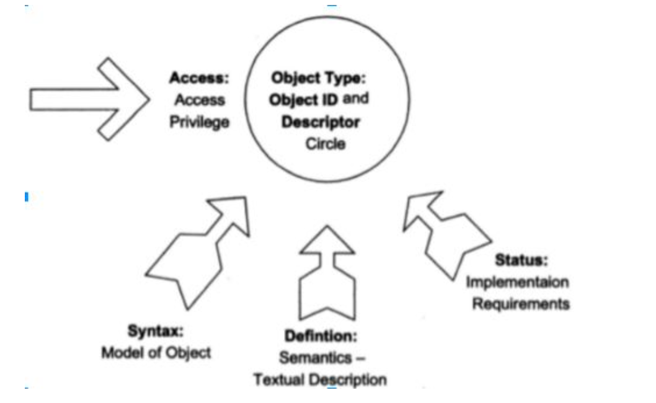

* Object Identifier (OID): Each managed object is uniquely identified by an OID, which serves as its address.
* Definition: Provides additional information about the purpose, usage, or characteristics of the managed object.
* Status: The status attribute indicates the operational status of the managed object, such as whether it is active, inactive, or deprecated.
* Data Type: Managed objects have a defined data type that specifies the kind of information they represent. Common data types include integers, strings, counters, timestamps, and Booleans.
* Access Control: Managed objects have access control mechanisms that specify the operations allowed on them. Access control defines whether an object can be read, written, or both.

OR

Notes
Managed Object:
Internet Perspective
•object ID unique ID
•and descriptor and name for the object
•syntax used to model the object
•access access privilege to a managed object
•status implementation requirements
•definition textual description of the semantics
of object type
Network Management: Principles and Practice
© Mani Subramanian 2000
3-23
ObjectType:
ObjectID and
Descriptor
circle
Access:
Access
privilege
Defintion :
Semantics-
textualdescription
Status :
Implementaion
requirements
Syntax :
modelofobject
Figure3.9(a)InternetPerspective
Chapter 3
 

2.Compare MDB and MIB. 2M

3.Explain scoping and filtering in CMIP. 2M

<https://www.ques10.com/p/41304/what-is-scoping-and-filtering-in-cmipcmis-networ-1/>

Three levels

* Base object
* Nth level
* Entire sub-tree: all the nodes of base object

4.Explain the Dumbell architecture of network management.

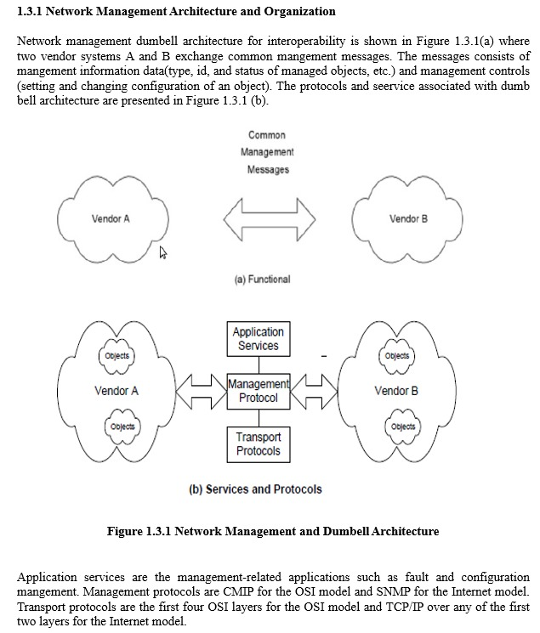

5.Explain Management Information Tree.

6.Draw the PDU of CMIP (common management information service elements ).

7.Explain the challenges of IT manager.

8.Explain service management in network management.

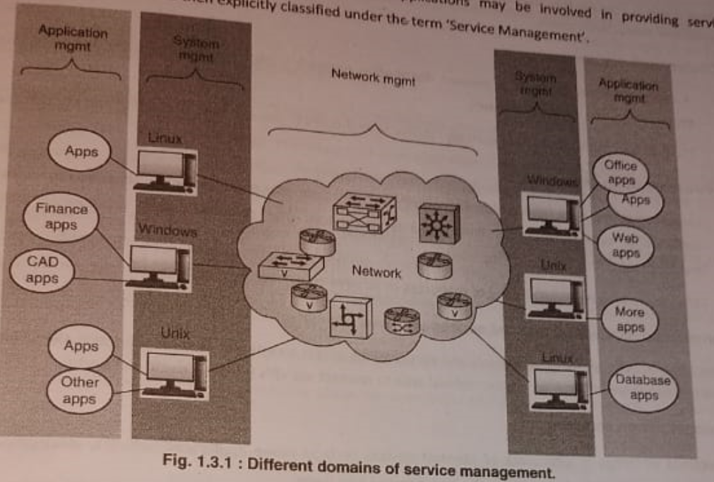

1. Network Management: Overseeing the operation of the entire network infrastructure, including devices like routers, switches, firewalls, and servers. It includes tasks such as monitoring network performance, configuring devices, managing network traffic, and troubleshooting network issues.

2. System Management: System management focuses on the management of individual systems or servers within the network. This includes tasks such as installing and configuring operating systems, managing software applications, monitoring system performance, ensuring system security, and performing backups and recovery procedures.

3. Application Management: Application management involves managing the software applications and services running on the network. This includes tasks such as deploying and updating applications, monitoring application performance and availability, ensuring compatibility between different applications, managing licenses, and troubleshooting application-related issues.

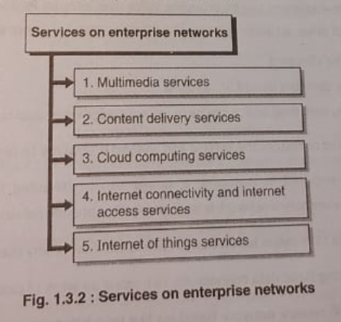

1. Multimedia Service: Delivering audio, video, and interactive media over the network.
2. Content Delivery Service: Distribution of digital content to users.
3. Cloud Computing Service: On-demand access to computing resources over the internet.
4. Internet Connectivity and internet Access: Providing access to the internet and related devices.
5. Internet of Things (IoT) Service: Connectivity and communication between internet-enabled devices.

9.Explain in detail ASN.1

10.Explain the functional architecture of OSI model in detail

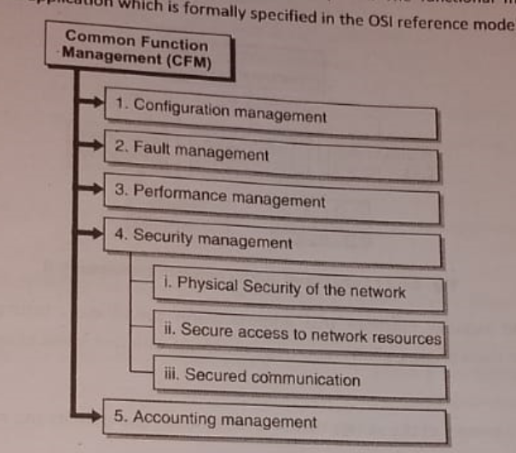

1. Configuration Management: Controls network device configurations to ensure proper setup.
2. Fault Management: Detects, isolates, and resolves network faults or abnormalities to maintain uptime.
3. Performance Management: Monitors and optimizes network performance to ensure efficient operation.
4. Security Management: Protects network resources from unauthorized access and malicious attacks.
5. Physical security of the network: it should be secured against any damage.
6. Secure access to the network resources: providing access to the authorized users.
7. Secured communication: deals with securing the transmitted information.
8. Accounting Management: Tracks and records network resource usage for billing, auditing, and reporting purposes.

11.Explain MIB.

12.Compare Agent process and Manager process. 2M

13.Draw the PDU (Packet Data Unit) of Trap. 2M

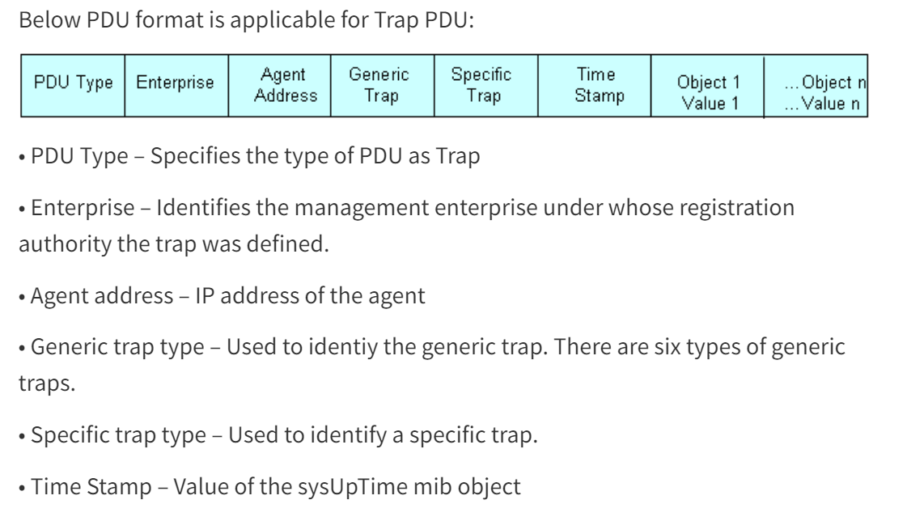

1. PDU Type: specifies the type of PDU as trap (Type=4)
2. Enterprise: it contains an object identifier (OID) unique to each enterprise.
3. Agent address: Represents the IP address of the SNMP agent that generated the trap.
4. Generic trap type:
5. Cold Start
6. Warm Start
7. Link Down
8. Link Up
9. Authentication Failure
10. EGP Neighbor Loss
11. Specific trap type: provides more detailed information about the cause/trap.

For example,

* Generic Trap Type: Link Down
* Specific Trap Type: Hardware Failure

1. Time stamp: value of system uptime.

15. Explain the two-tier architecture of SNMP.

16. Explain OAMP in network management.

OAMP stands for operations, administration, maintenance, and provisioning.

The ” O ” in OAMP : It includes monitoring the network and finding problems. Ideally these problems should be found before users are affected.

The ” A ” in OAMP : Administration these are the support procedures performed on a network e.g. allocation of passwords.

-

The ” M ” in OAMP : Maintenance is performed to keep the network operating smoothly, including configuring updates or aligning to new policy and regulations.

The ” P ” in OAMP: Provisioning is used to configure the network to provide new services, whereas OAM is used to keep the network in a state that it can support already existing services.

17. Explain network management standards and their features.

1. OSI Model (open systems interconnection)
   * Features: Divides network communication into seven layers, providing a standardized framework for understanding and implementing network protocols and services. Layers include physical, data link, network, transport, session, presentation, and application.
2. Internet Model:
   * Features: Based on the TCP/IP protocol suite, it's a simplified version of the OSI model, focusing on four layers: network interface, internet, transport, and application layers. Emphasizes flexibility, scalability, and interoperability, key for internet-based communications.
3. Telecommunication Management Network (TMN):
   * Features: Provides a framework for managing telecommunication networks and services. Consists of functional areas like FCAPS (Fault, Configuration, Accounting, Performance, Security), defining key aspects of network management.
4. IEEE LAN Model:
   * Features: Developed by the Institute of Electrical and Electronics Engineers (IEEE), it defines standards for local area network (LAN) architectures and protocols. Includes the logical link control (LLC) and media access control (MAC) layers, with standards like Ethernet and Wi-Fi.
5. Web-Based Management Model:
   * Features: Utilizes web technologies for managing network devices and services, providing a user-friendly interface accessible via web browsers. Often employs protocols like HTTP, SNMP, or RESTful APIs for configuration, monitoring, and control.

18. Explain the significance of Trap. Describe the different types of traps. 6M

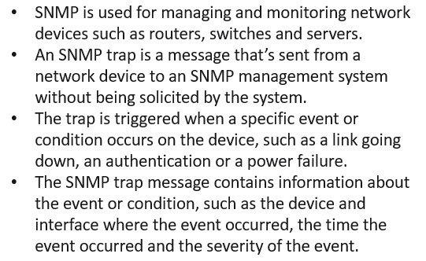

There are three types of traps— **generic-trap, specific-trap, and time-stamp**, which are application specific.

Generic Trap:

1. Cold Start: Indicates that the SNMP agent has restarted and is initializing.
2. Warm Start: Indicates that the SNMP agent has restarted without reinitializing.
3. Link Down: Indicates that a network interface has gone offline.
4. Link Up: Indicates that a network interface has come online.
5. Authentication Failure: Indicates a failed attempt to authenticate with the SNMP agent.
6. EGP Neighbor Loss: Indicates the loss of an Exterior Gateway Protocol (EGP) neighbor.

Specific Traps: Specific traps, also known as enterprise-specific traps, are custom traps defined by individual vendors or organizations unlike generic traps, which have well-defined codes by SNMP. Organizations can define specific traps to monitor event specific to their network environment.

Time stamp Trap:

19. Explain the Administrative policy of communication model. 6M

